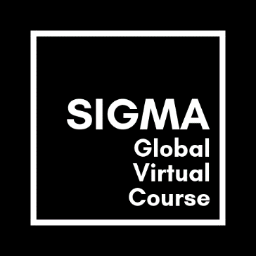

Sigma Case Cast

1 Prepare your CaseCast following the grid provided.
2 The rubrics, which your instructors will use for grading the CaseCast, provide information on the structure and content of the CaseCast.
Aspects to be addressed | Additional information
Present the organization you are working on for your good practice case study. | The first part of your Case Cast provides the context information about your organization. Due to the time restrictions this part should not be longer than approximately 1 minute.
Describe the organizational/industry background.

What SDGs does the organization address?

What does the organization do particularly well in addressing selected SDGs? | The second part provides your findings. This is the main part of the Case Cast. It should explain to the audience why your organization is an example of a good practice.
Why does the organization succeed? What factors of success can you identify?

Are there remaining challenges for the organization? What recommendations would you give them?

3 Bear in mind that your CaseCast must not be longer than 2.5 minutes!

