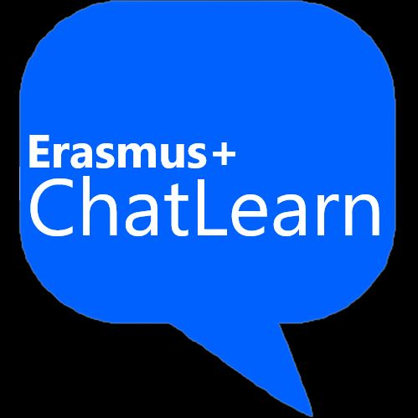

Future of Teaching and Learning Conference:
AI Applications in Project Management and beyond
Workshop Proposal Template
Note: Please fill in the information between squared brackets [ ]. Delete when not applicable.

[Title]

Keywords:
[1-4 keywords ]

Workshop coordinator: [(Name Surname), Department (if applicable), Institution, City, Country, Email address]

Workshop contributors:
[ Panelist 1 (Name Surname), Department (if applicable), Institution, City, Country ]
[ Panelist 2 (Name Surname), Department (if applicable), Institution, City, Country ]
[ Panelist 3 (Name Surname), Department (if applicable), Institution, City, Country ]

Workshop contributors bios:
[Panelist 1 bio]
[Panelist 2 bio]
[Panelist 3 bio]

Abstract of the workshop (800 words maximum): [ ]

Workshop design and engagement with audience (60 minutes): [ ]

