Open Call for Bachelor Thesis Supervision – 5 Projects available
How deep is our Carbon-Lock-in?
Can we escape fossil fuel dependence?
What are the economic and social vulnerabilities involved?
These are questions that are extremely pertinent in times of climate change and geopolitical tensions in the middle east. ISSET, the Institute for Spatial and Social-Ecological Transformations, at the Department of Socioeconomics at WU is offering five potential bachelor thesis projects under the supervision of Assistant Professor Mag. Dr. Christian Kerschner. The idea is a collective exploration of five different ideas, narratives or hypothesis by means of our browsable interface that allows country and sector level detection of carbon lock-ins and vulnerabilities in the case of fossil fuel restrictions. This interface was developed in our EU Project i-CONN (Global Economic Vulnerability: https://global-economic-vulnerability.onrender.com). With this tool we have now a large pool of data and combinations that need analysing with a specific research question in mind. Our dataset includes 163 sectors across 44 countries and five rest-of-world regions over the period of 1995-2022. For instance, one of the things we have already asked, is whether sectors that are necessary for decarbonisation (i.e. renewable energy and their supply chains) are also vulnerable when we want to phase out fossil fuels. Which they are and which of course is not good news. But there are still many other questions that we have not asked and investigated with our tool. This is where YOUR Thesis could come in!
You find some more details on background and results so far below that you can check out. If you are interested to join us in this effort, please reach out to christian.kerschner@wu.ac.at
Short Background
In our current times of a global “polycrisis” (Lawrence et al., 2024), economies around the world face multiple environmental, social and political challenges. The most prominent of these relate to the extraction and use of hydrocarbons as critical production inputs and main energy sources, increasingly shaped by climate change (Foster et al. 2026) and the geopolitics and weaponisation of energy, exemplified by the closure of the Strait of Hormuz. Decarbonisation based on resilience-oriented economic restructuring that avoids expanding extractivism and neo-colonialism is a central strategy for addressing these challenges (Riofrancos 2023; Gatto & Magazino 2026). Yet effective and socially just decarbonisation first requires understanding where economies maintain strong levels of carbon-lock-in and remain structurally vulnerable in the case of a fossil-fuel phase-out (decarbonsiation).
Multi-regional input-output studies show energy-price shocks propagating through production networks, raising household expenditure and poverty risk (Guan et al. 2023) and reducing access to essential goods and services (Zhang et al. 2023). Combined with complex-network metrics, this approach can also reveal the nodes through which disruptions spread most forcefully, as shown for global natural gas networks (Du et al. 2022). Managing the transition away from fossil fuels in socially sustainable ways has so far been studied mainly via household carbon footprints and emissions inequality (Dorninger et al. 2021) and the employment implications of decarbonisation pathways (Černý et al. 2024). However, no existing framework links structural measures of carbon lock-in to macroeconomic performance, consumer-price dynamics and socio-economic vulnerability across countries. Consequently, it remains unclear whether structural fossil-fuel dependence helps explain why economies respond differently to energy shocks and which households and workers are most exposed during decarbonisation.
Our team has developed a respective measure that combines state-of-the-art input-output approaches with network analysis (Kerschner et al. 2013; Diaz et al., forthcoming). Using longitudinal EXIOBASE multi-regional input-output data (1995–2022; Stadler et al. 2018) covering 163 sectors across 44 countries and five rest-of-world regions, our results — most recently within the H2020 i-CONN project — reveal a worrying increase in global fossil-fuel vulnerability and carbon lock-in, concentrated in a growing number of sectors that are both highly vulnerable and system-critical, such as chemicals, fertilisers and plastics (Figure 1C), as well as sectors central to the energy transition itself. The global economy, in other words, is deepening its carbon lock-in and the way out seems ever more difficult.
(A)
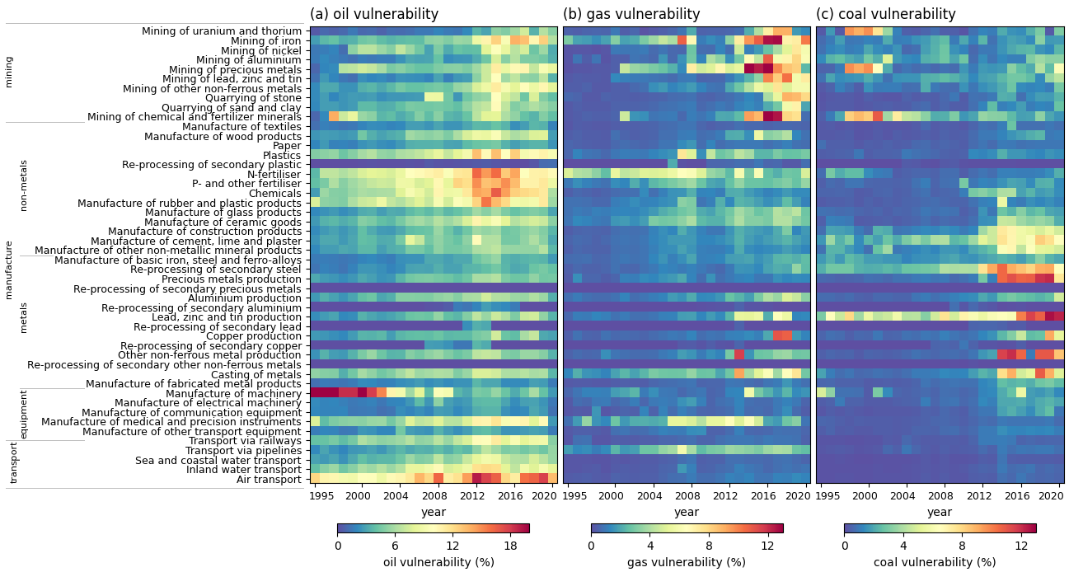

(B)
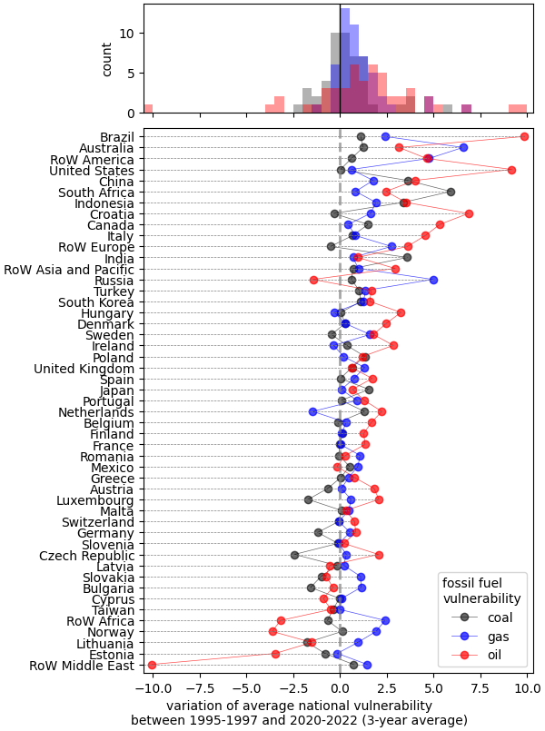

(C)
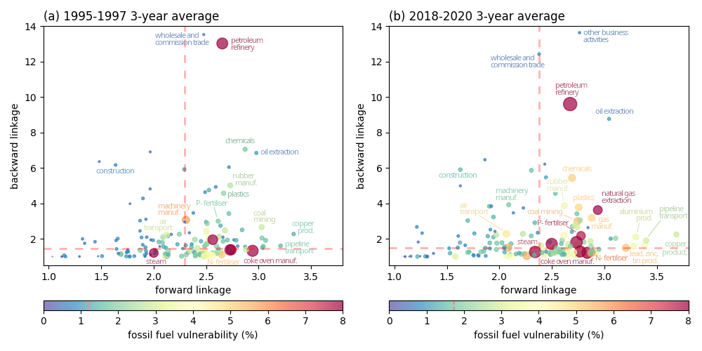
Figure 1. (A - Heatmaps) Global vulnerability to a fossil fuel price shock for oil, gas and coal, respectively, at the sectoral level from 1995 to 2020. (B - Bar plots) Ranking of countries which have increased their vulnerability to a gas, oil or coal price shock. between 1995 and 2020. (C – Bubble graphs) Global sectoral vulnerability by sectors’ economic importance between 1995 and 2020. Average vulnerability for sectors in the key quadrant is displayed in each plot. Both, the size and the colour of the bubbles stand for the degree of vulnerability of each sector. Labels are displayed conditional to vulnerability values (if higher than a certain threshold). (source Diaz et al forthcoming)

Note: With this article we are also providing an interface, where users can analyse specific local contexts i.e. to determine check how prepared the sectors of a specific country or region are for phasing out fossil fuels: Global Economic Vulnerability

- Černý, M., Bruckner, M., Weinzettel, J., Wiebe, K., Kimmich, C., Kerschner, C., & Hubacek, K. (2024). Global employment and skill level requirements for 'Post-Carbon Europe'. Ecological Economics, 216, Article 108014. https://doi.org/10.1016/j.ecolecon.2023.108014
- Díaz Muñoz, M., Haj-Ali, S.M., Hütt, M., Kerschner, C., (forthcoming). Global economic vulnerability data on fossil fuel disruptions reveals decarbonisation efforts are increasingly threatened by an escalating carbon lock-in (working title)
- Du, R., Wu, Q., Nan, Z., Dong, G., Tian, L., & Wu, F. (2022). Natural Gas Scarcity Risk in the Belt and Road Economies Based on Complex Network and Multi-Regional Input-Output Analysis. Mathematics, 10(5), Article 5. https://doi.org/10.3390/math10050788
- Dorninger, C., Hornborg, A., Abson, D. J., von Wehrden, H., Schaffartzik, A., Giljum, S., Engler, J.-O., Feller, R. L., Hubacek, K., & Wieland, H. (2021). Global patterns of ecologically unequal exchange: Implications for sustainability in the 21st century. Ecological Economics, 179, Article 106824. https://doi.org/10.1016/j.ecolecon.2020.106824
- Forster, P. M., et al. (2026). Indicators of Global Climate Change 2025: Annual update of key indicators of the state of the climate system and human influence. Earth System Science Data, 18, 3889–3933. https://doi.org/10.5194/essd-18-3889-2026
- Gatto, A., & Magazzino, C. (2026). The polycrisis needs a sustainability- and resilience-oriented paradigm shift through innovation. Environmental Science & Policy, 180, 104371. https://doi.org/10.1016/j.envsci.2026.104371
- Guan, Y., Yan, J., Shan, Y., Zhou, Y., Hang, Y., Li, R., ... & Hubacek, K. (2023). Burden of the global energy price crisis on households. Nature Energy, 8(3), 304-316. https://www.nature.com/articles/s41560-023-01209-8
- Kerschner, C., Prell, C., Feng, K., & Hubacek, K. (2013). Economic vulnerability to peak oil. Global environmental change, 23(6), 1424-1433. https://doi.org/10.1016/j.gloenvcha.2013.08.015
- Miller, R. E., & Blair, P. D. (2009). Input-output analysis: foundations and extensions. Cambridge university press.
- Lawrence, M., Homer-Dixon, T., Janzwood, S., Rockstöm, J., Renn, O., & Donges, J. F. (2024). Global Polycrisis: The causal mechanisms of crisis entanglement. Global Sustainability, 7, e6. https://doi.org/10.1017/sus.2024.1
- Riofrancos, T. (2023). Extraction: The frontiers of green capitalism. Haymarket Books. http://www.theariofrancos.com/extraction
- Stadler, K., Wood, R., Buber, T., Bruckner, M., Giljum, S., de Koning, A., Kuenen, J., Acosta-Fernández, J., Usubiaga, A., Simas, M., Ivanova, O., Weinzettel, J., Schmidt, J.H., Merciai, S. and Tukker, A. (2018). EXIOBASE 3: Developing a Time Series of Detailed Environmentally Extended Multi-Regional Input-Output Tables. Journal of Industrial Ecology, 22(3):502-515. DOI: 10.1111/jiec.12715
- Zhang, Y., Shan, Y., Zheng, X., Wang, C., Guan, Y., Yan, J., ... & Hubacek, K. (2023). Energy price shocks induced by the Russia-Ukraine conflict jeopardize wellbeing. Energy Policy, 182, 113743. https://doi.org/10.1016/j.enpol.2023.113743

